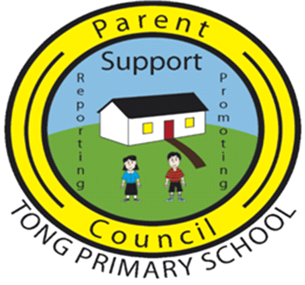

TONG PRIMARY SCHOOL PARENT COUNCIL AGM

13th JUNE 2023

PRESENT:
Marina MacLeod Chair, Parent Council
Isla MacDiarmid Treasurer, Parent Council
Ann Marie MacLennan Vice Chair, Parent Council
Dianne Weatherston Secretary, Parent Council
Lynne Rough Parent Council
Emma MacLean Parent Council
Ann-Marie Beaton Acting Head Teacher
Shona MacDowall Acting Principal Teacher
Becky Parent
Jenny Kearns Parent
Donald Crichton Councillor

Marina welcomed everyone to the meeting.

Apologies from Calum MacLean and John A MacIver.

MINUTES OF THE AGM 14th JUNE 2022
The Minutes were approved as an accurate record.

MATTERS ARISING
Canteen Arrangements
Ann-Marie advised that hot canteen meals will contine to be prepared in Back School. From the start of the new term in August 2023, children will be able to eat in the dining hall in the school. The arrangements for eating over at Tong Hall will cease.

TREASURER'S REPORT
The closing balance was £2956.21.

The Fun Day raised £910.79 in profit after all expenses, which was really positive.

COUNCILLOR'S REPORT
Donald advised that a new campus for Tong School remains a priority for the Education Deptartment and local councillors. He added that it is not possible to keep adding to the exising campus, and that the councillors will keep pushing for this.

Parent Council raised concerns that CnES wont invest in Tong School as its a buiding that wont be here permanently. Donald noted that capital is very tight in terms of resources.

Marina asked if there's anything else that can be offered to Tong School, for example funding for staff to run after school clubs rather than parents volunteering. Donald suggesteed inviting Donald Macleod, Head of Education to a future meetng so that this can be discussed with him.

Shona advised that Stornoway Primary is the only school that has funded after school clubs. They are allocated this funding due to high role numbers. She noted that funding of this nature for Tong School would be a welcome investment from CnES.

FUNDRAISING REPORT
A fundraising meeting will take place in September to discuss a plan for fundraising for next session.

COST OF THE SCHOOL DAY
It was agreed to carry on with the calendar that goes out at the start of the year, and this will be agreed between the school and Parent Council. Carol Anne will take this forward when she returns from maternity leave.

ELECTION OF OFFICE BEARERS
Chair - Marina MacLeod
Fundraising Lead - Emma MacLean (and one other person TBC)
Vice Chair - it was agreed that there is no need for a Vice Chair
Treasurer - Isla MacDiarmid
Secretary - Dianne Weatherston

Dates - Parent Council 2023/24
12th September 2023
14th November 2023
13th February 2024
23rd April 2024
11th June 2024 (AGM)

The first meeting will start at 7.30pm, with a view to starting earlier at 7pm going forward.

It was agreed that meetings will be kept short.

AOB
Marina thanked Ann-Marie for all her help, and wished her the best of luck with her maternity leave on behalf of Parent Council. Ann-Marie thanked everyone and wished them all the best.

DATE OF NEXT MEETING
12th September 2023

Marina closed the meeting and thanked all for their attendance.

END

