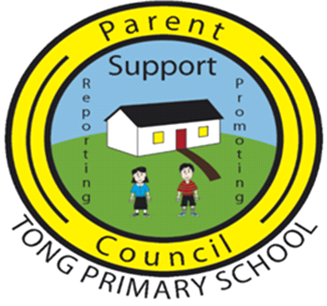

A Meeting of the PTA took place on 2nd May 2022, 7.30pm in Tong School

PRESENT:
Isla MacDiarmid Treasurer, Parent Council
Dianne Weatherston Secretary, Parent Council
Lynne Rough Parent Council
Emma MacLean Parent Council
Ann-Marie Beaton Acting Head Teacher
Joanne Cheesman Teacher

Lynne welcomed everyone to the meeting. She chaired the meeting in the absence of Marina and Ann-Marie M.

Apologies from Marina MacLeod, Ann-Marie MacLennan, Karen Miller, Donald Crichton, Calum MacLean and John A MacIver.

MINUTES OF 14TH FEBRUARY 2023
The Minutes were approved as an accurate record.

MATTERS ARISING
Container
The new container is now in use, and this has helped resolve some of the storage issues.

PE Equipment
The new PE equipment order from Strada is with Ann-Marie B. The new equipment will be ready for use at the start of the new school year in August 2023.

Canteen Building
As noted at the last meeting, The proposed new canteen building has been approved, pending funding. The provisional date is still November 2023.

TREASURER’S REPORT
Isla went through the Treasurer’s Report. A copy of the report is attached for ease of reference.

COUNCILLOR’S REPORT
No report presented and no councillors in attendance at the meeting.

FUNDRAISING REPORT
The Fundraising Lead role is still vacant. There has been no interest shown by anyone to take on this role.

The suggested date for the Fun Day is 16th June. A Group Call will be issued looking for volunteers. Help is required for set-up, manning stalls and tidying up. It will be made clear that the Fun Day cannot go ahead without enough volunteers.

It was suggested that Parent Council could hold a bake sale and tea/coffee at Sports Day if there aren’t enough volunteers for the Fun Day.

The fundraising for the P7 trip has gone very well. A meeting with P7 parents will take place on Thursday to discuss final costs now that fundraising is complete.

FUN DAY
This was discussed under Fundraising Report.

HEAD TEACHER’S REPORT
Ann-Marie went through the Head Teacher’s Report. A copy of the report is attached for ease of reference.

iPad are expected to be delivered imminently, however a date is still to be confirmed. There are 14 iPads for Tong School.

COST OF THE SCHOOL DAY
Not discussed.

CANTEEN PROVISION
Dianne raised that some pupils have been complaining about the cold temperature of the canteen food. Ann-Marie B will check with the canteen staff and feedback.

AOB
Emma queried why Michael is crossing children from the school side of the road in the mornings, rather than the hall side. Ann-Marie B will check and feedback.

DATE OF NEXT MEETING
6th June 2023

Lynne closed the meeting and thanked all for their attendance.

END

