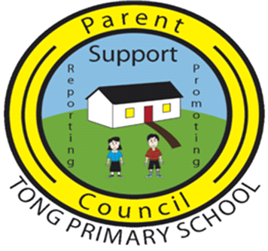

A Meeting of the PTA took place on 14th February 2023 at 7.30pm in Tong School

PRESENT:
Marina MacLeod Chairperson, Parent Council
Isla MacDiarmid Treasurer, Parent Council
Lynne Rough Parent Council
Emma MacLean Parent Council
Kirsty MacAulay Principal Teacher
Ann-Marie Beaton Acting Head Teacher
Jenny Kearns Parent Council
Karen Miller Parent Council
Laura Carse Parent Council
Donald Crichton Councillor
Calum MacLean Councillor

Welcome/Apologies
Marina welcomed everyone to the meeting.

Apologies from Alyson MacIver, Ann-Marie MacLennan, Donna Murray and Dianne Weatherston.

MINUTES OF 15TH NOVEMBER 2022
The Minutes were approved as an accurate record.

MATTERS ARISING
New Container
The skip was filled and removed, and the old container has also been removed. The new container is expected to be installed week commencing 20th February 2023.

TREASURER’S REPORT
The Treasurer’s Report is attached for ease of reference.

COUNCILLOR’S REPORT
The proposed new canteen building has been approved, pending funding. A provisional date has been given as November 2023. Marina queried electrical supply for the new building, however no conclusive answer was provided. Ann-Marie B and Marina to discuss this separately with Donald MacLeod, CnES.

Due to capital budget cuts from 2023 through to 2027, the likelihood of a new build school for the Broadbay area is unlikely to be progressed in the near future.

FUNDRAISING REPORT
Alyson MacIver has stepped down as Fundraising Lead. Unfortunately, no volunteers have come forward to replace her in the role.

Ann-Marie B proposed changes to the previous P7 fundraising timetable to reflect that the trip is taking place in May rather than June this year.

P7s will hold toast mornings throughout March and April to raise funds for their trip.

HEAD TEACHER’S REPORT
The Head Teacher’s Report is attached for ease of reference.

COST OF THE SCHOOL DAY
It was agreed that dress down days will continue on an ‘optional donation’ basis.

World Book Day was discussed, and it was agreed that costumes will fall under the reuse/recycle category to keep costs minimal.

RSHP SHARING OF INFORMATION
Marina advised that following the Parent Council Chairs meeting that was held at eSgoil, she was very impressed and encouraged by the amount of work the committee put in to deliver an education programme that is more suitable for our children.

All parents will be fully informed of every aspect expected to be taught, and teachers will not be permitted to deviate from this. If parents do not wish their child to take part in certain aspects, or indeed any of the subjects, they have the right to withdraw their child from the lessons.

AOCB
Laura Carse offered £200 from her business to further Strada’s improvement of school’s provision for sport. Parent Council thanked Laura for the generous offer.
Start Time of Future Meetings
It was agreed that meetings will continue to start at 7.30pm.

Date of Next Meeting
2nd May 2023

Marina closed the meeting and thanked all for their attendance.

END

